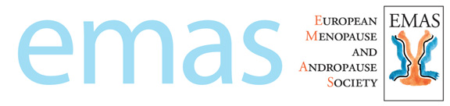
Invitation to become a Member of
the European Menopause and Andropause Society

Dear Colleague,
On behalf of The European Menopause and Andropause Society (EMAS) we would like to take this opportunity to introduce you to the society.
EMAS was founded to promote the study of all aspects of climacteric in both men and women, as well as to organise, prepare and participate in international meetings and congresses on subjects related to Menopause and Andropause, plus, to advance the interchange of research and experience between members of the society. EMAS is acknowledged by the International Menopause Society as the official Regional European Menopause Society.

We would like to invite you to join us to fulfill our mission and to become an EMAS member so we can support your efforts even more.
Benefits for Individual Members:
- A year's subscription to Maturitas (online & print), the official journal of EMAS, including supplements
- A substantial discount to the registration for the EMAS' congresses (16-20 May 2009 London, UK)
- Opportunity to participate in educational activities
- Access to the member's section of the EMAS website
- Quarterly EMAS newsletter
- Full voting rights at EMAS' General Assembly and a say in running the society

Please click here to sign up for your EMAS membership today.
For more information about EMAS please visit www.emasonline.org
National associations can also apply for membership.
We look forward to welcoming you as an EMAS member and meeting you at the next EMAS congress which will take place 16-20 May, 2009 in London, UK.
If you have any queries, please do not hesitate to contact us at membership@emasonline.org
With best regards,
EMAS Membership Services

